**MAD-1 Project Documentation**

**Project Name:** Ticket Show Application (FilmFrenzy)

**Author:**

**Name:** Soujit Das

**Roll:** 21f3001028

**Email:** [**mailto:21f3001028@ds.study.iitm.ac.in**](mailto:21f3001028@ds.study.iitm.ac.in)

**About Me:** I am a computer science engineering undergrad who is always open to new opportunities and learnings. I love to indulge with different tech stacks, learn things around them to solve real world problems. This project particularly gave me an idea about web development using Flask framework and simulate a real world like project from end to end.

**Introduction:**

The Ticket Show Application is a web-based application that allows multiple users to book movie tickets for different shows under different venues. The application has two parties - an admin and users. The admin can add/edit/delete movie shows, venues, and users, while the users can browse movies, view show timings, and book tickets. The web application consists multiple API’s to add/edit/delete venues and shows by the admin side.

**Technology Stack:**

* **Flask:** Flask is a Python web framework that provides tools, libraries, and patterns to build light -weight web applications.
* **Flask SQLAlchemy:** Flask SQLAlchemy is a library that provides a set of high-level API for connecting Python objects to relational databases.

* **Flask Login:** Flask Login is a library that handles user authentication and authorization in Flask applications.
* **Werkzeug:** Werkzeug is a library that provides various utilities for handling HTTP requests and responses. Here Werkzeug.security package is used for generating password hashing and check password hash.
* **SQLite:** SQLite is a lightweight, embedded relational database that provides a simple and efficient way to store and retrieve data.
* **Bootstrap:** Bootstrap version 4.1 is used in this project for the HTML styling and overall frontend designing.

**Features:**

The Ticket Show Booking Application has the following features:

Admin Panel - An admin panel is provided for the administrator to manage the application. The admin can add/edit/delete movie shows, venues, and users. The admin can also view the list of bookings made by users.

User Panel - A user panel is provided for the users to browse movies, view show timings, and book tickets. Users can search movies by title or genre and can filter by venue or date. Users can also view their booking history and see/edit their profile. Users has also the capability to rate the shows as per their choice

Authentication and Authorization - The application has a login page where users can authenticate themselves. The admin panel is protected and can only be accessed by the admin after authentication.

Ticket Booking - Users can select the movie show, venue, and show-timing and book tickets for the show. The application supports multiple ticket booking for the same show and once the show is completely houseful the booking stops for that particular show.

**Database Schema:**

The database schema for the application is as follows:

* Venues - This table stores the details of the venues.
* 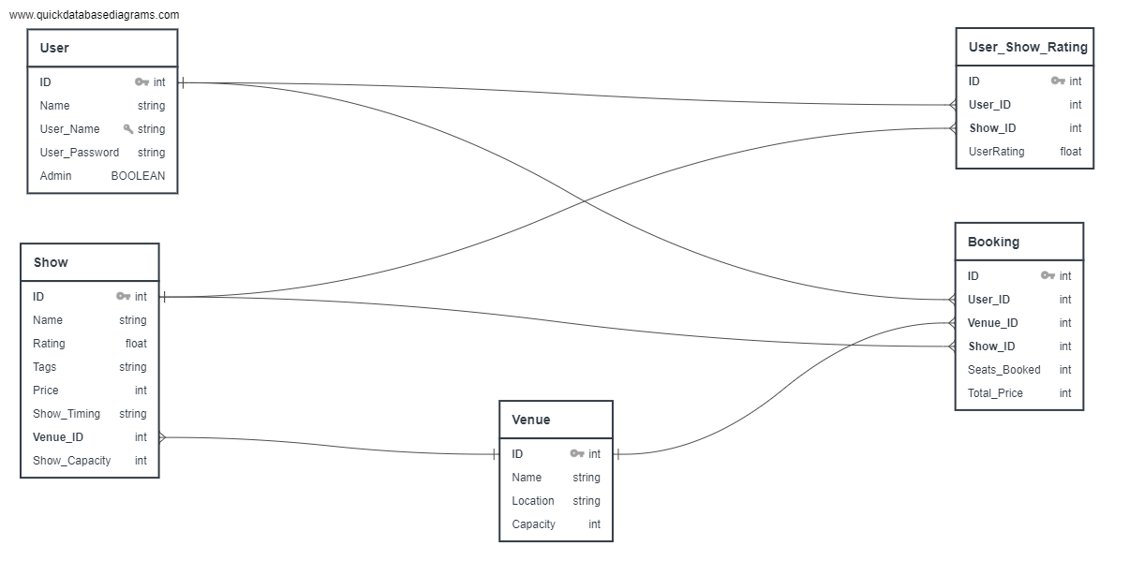Shows - This table stores the details of the movie shows.
* Users - This table stores the details of the users as well as admin.
* Bookings - This table stores the details of the bookings made by the users.
* User-Show-Rating(USR)- This table stores the ratings for a particular show by a particular user. It helps in calculating dynamic average rating of a show

Fig: Database Relationships Diagram

**Conclusion:**

The Ticket Show Booking Application (FilmFrenzy) is a user-friendly and efficient web-based application that allows users to book movie tickets for different shows under different venues. The application provides an easy-to-use interface for browsing movies, viewing show timings, and booking tickets

The Model-View-Controller (MVC) paradigm is used to organise the entire project. The controllers for processing requests and rendering templates are located in the views module of the application package. Controllers for handling user authentication and authorisation are present in the authentication module. Classes for database tables can be found in the models module. The HTML view templates are located in the templates folder. The application provides user registration and login, CRUD of shows/venues by admin, booking of shows by users, user ratings, distribution of dynamic average ratings to shows based on users' ratings, and multiple bookings by users. Moreover, the user can alter their username and password in My Profile section.

**Video Link:** [**https://drive.google.com/file/d/1NW9tCFzwyKD-7zsrfG4aWNzAIioH8GWK/view**](https://drive.google.com/file/d/1NW9tCFzwyKD-7zsrfG4aWNzAIioH8GWK/view)